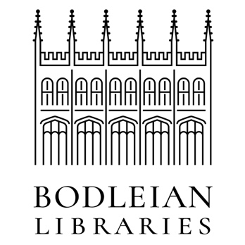
No innate ideas transcript
Speaker 1
Locke thought that the mind starts out like a blank sheet of paper in the sense that until we've had experience, we have no ideas to think with, and all of our ideas come through experience, and in particular, sensory experience.
Getting ideas through our senses.
Now, some of our senses are very familiar to us. Sight, touch, smell, taste. But in addition, Locke thought we had a sort of internal sense, a sense whereby we can perceive what is going on in our own minds, and thus get ideas of mental activities like perception or thinking or doubting, or believing or willing.
So he said that there were two great fountains from which all of our ideas come. And one of them is external sense and one of them is this internal sense. And until we've got ideas through one of those senses, our mind is, as he said, just a blank sheet of paper.
Now, in this respect, Locke was responding to Descartes. Descartes also used the term idea for the things that we think about the contents of our mind.
But Descartes thought that God had structured our minds in such a way that we could get certain ideas, like the idea of God, like the idea of extended substance, just by using our own intellect without any sensory input.
So Locke was reacting to that, and saying no, all of our ideas, all of our thoughts come through experience, and in particular sensory experience. Without that, we would just have this blank sheet of paper.

Speaker 2
Let us suppose the mind to be, as we say, white paper void of all characters without any ideas. How comes it to be furnished? Whence comes it by that vast store, which the busy and boundless fancy of man has painted on it with an almost endless variety. Whence has it all the materials of reason and knowledge?
To this I answer in one word from experience.

Speaker 3
Locke’s claim has many consequences. For example, it has the consequence that we are not born with any knowledge of language. We have to learn everything abstracting from our ideas and this is a very important thing in Locke.
We perceive individual things, individual horses, individual men and women, and we abstract from this perception the general idea of a man or a woman, or a horse, and this is how we had to learn all things.
So learning language had to be this way, according to Locke, that we associate words with ideas, but these ideas must come from experience is nothing that we were born with.
People will attach very different ideas to different words, because Locke thought of ideas in terms of experiences, in terms of the perceptual experiences that people had this also meant that people could attach words to very different kinds of experiences.
So for example, if you had an experience of red well at the same time I had an experience of blue.
We could nonetheless attach the same words for those experience and we would never know whether we were talking about the same thing. What you called red was what I called blue, and what you called blue was when I called red, but it was undetectable from the outside.
Modern science does not agree with Locke that there are no innate ideas. Modern psychology and theories of language are very committed to the idea that we are born with some fundamental, possibly universal ways of responding to the world in particular, for example, Noam Chomsky has argued that the knowledge of language is innate.
We are born with a knowledge of something universal which we then activate when we start to speak, but that knowledge was there from when we were born.
Some psychologists think that we were born with a knowledge of how the physical world works, that they call intuitive physics, and that this is part of our innate endowment. So Locke’s ideas here would be very controversial today.

